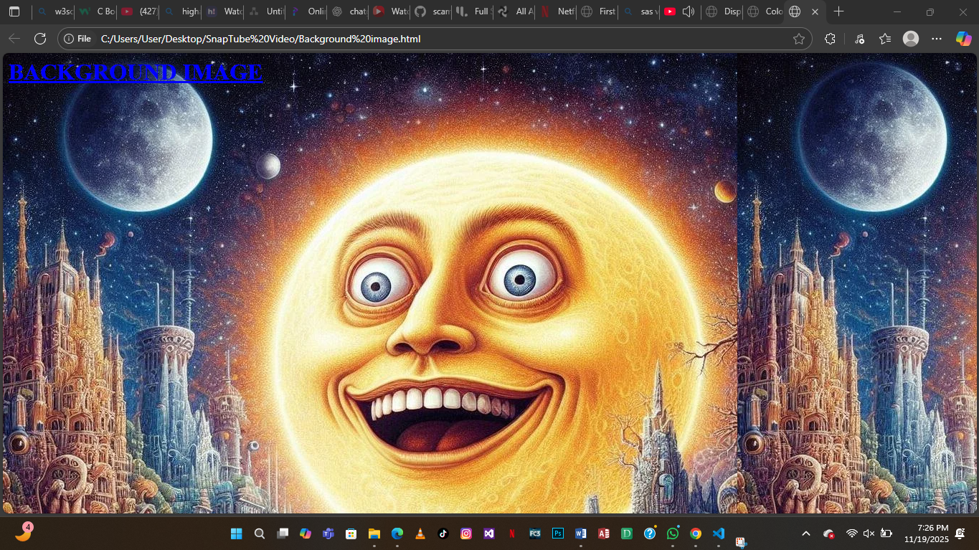
<!DOCTRYPE html>
<html>
<head><Title>Background Image</Title></head>
<h1 style="color: blue;"><u>BACKGROUND IMAGE</u></h1>
<body background="https://preview.redd.it/the-most-random-image-every-seen-in-the-history-of-the-v0-iuzrc59aw2sb1.jpg?width=1024&format=pjpg&auto=webp&s=dd018a25303363415b10f1906c2d4b25fa47043f" height="200" alt="This is an online image">

</body>
</html>

